**Game Idea**

Description:  
 GameTracker is a web application that enables users to register and manage their video games. Users can update the status of their games (e.g., Completed, Playing, Paused) using a dropdown menu and add notes for each game. The application tracks relationships between users and their games, providing a comprehensive view of their gaming experiences.

**User stories:**

1. User Registration:

* As a new user, I want to create an account (Create) so that I can track my games.
* As a returning user, I want to log in to my account (Read) to access my game list.

1. Games Management:

* As a user, I want to add a new game to my collection (Create) so that I can keep track of it.
* As a user, I want to view a list of all my games (Read) along with their statuses and notes.
* As a user, I want to update the status of my game (Update) to reflect my current progress.
* As a user, I want to add or edit notes for each game (Update) to remember my thoughts or experiences.
* As a user, I want to delete games from my list (Delete) that I no longer want to track.
* As a user, I want to like the games from all game's lists.

1. User Interaction

* As a user, I want to see all the games stored in the database along with their statuses and notes so that I can review my complete collection and compare it with others.

**Data model:**

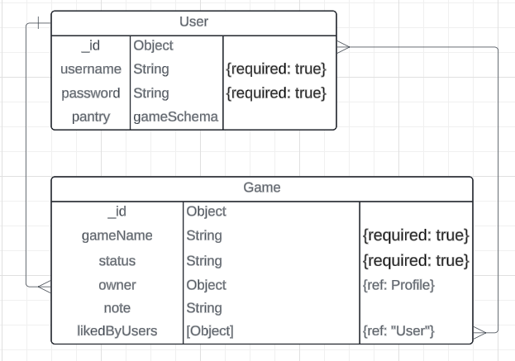

Mock-up:

App page:

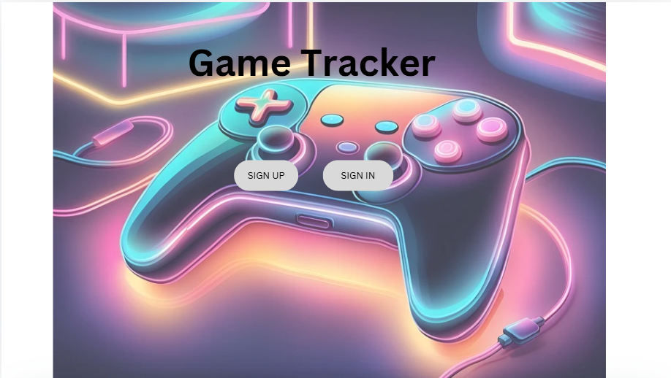

Sign-up page:

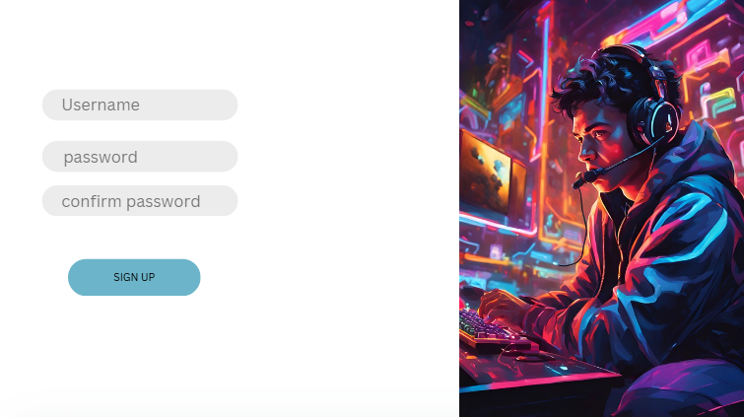

Sign-in page:

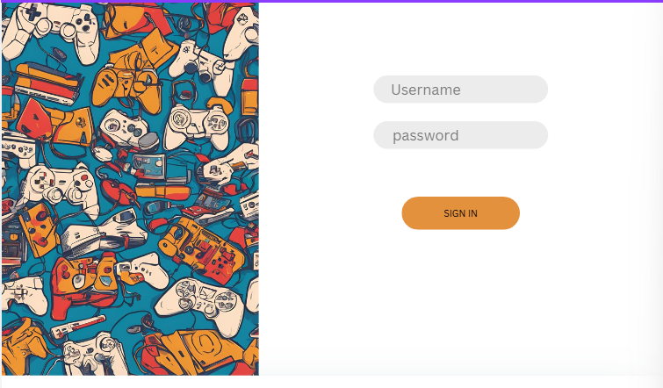

Home page:

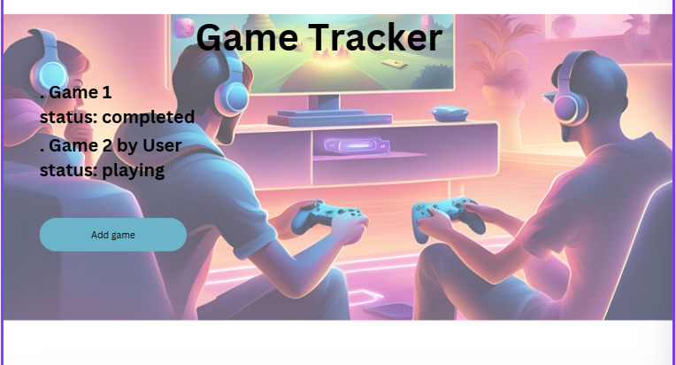

Add game page:

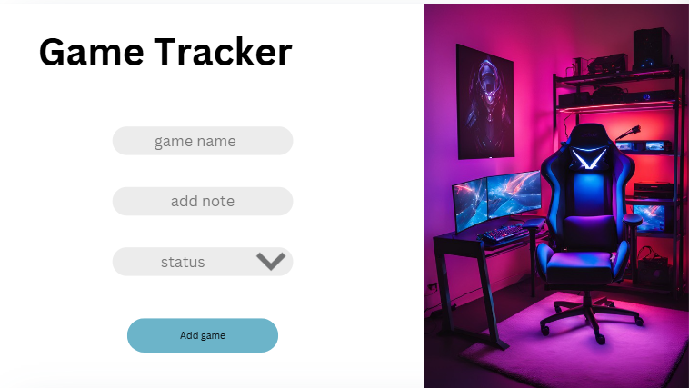

Show game page:

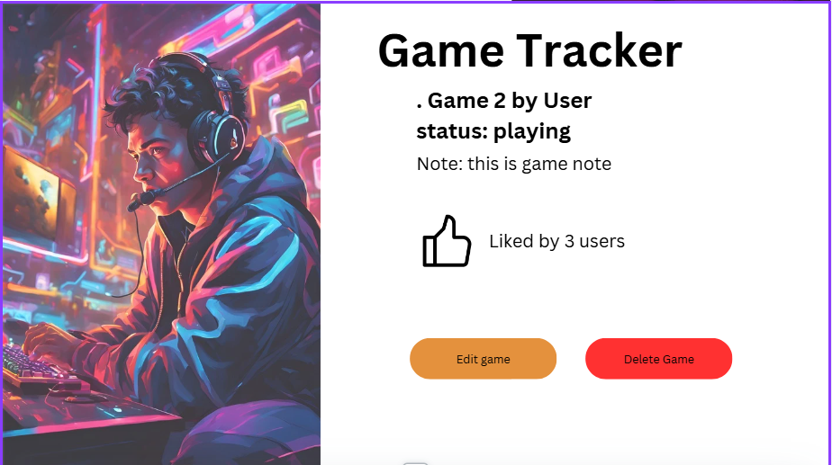

Edit game page:

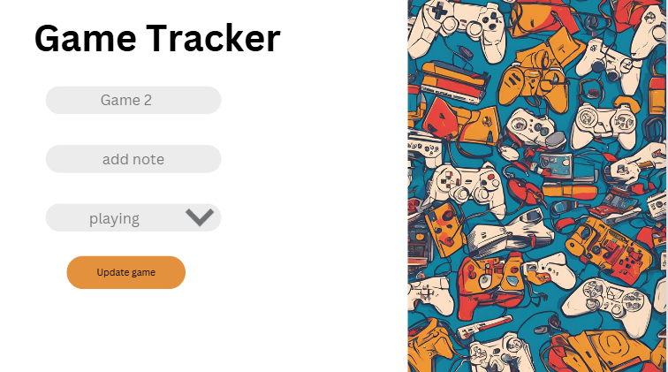

**Game Logic (pseudo code):**

**Adding a New Game:**

* When a user wants to add a new game, they provide the game name, status (selected from a dropdown), and notes.
* The system creates a new game entry in the database, associating it with the user's ID.
* The system confirms that the game has been successfully added.

Viewing All Games:

* When a user wants to see all games stored in the database, the system retrieves all game entries.
* The system displays the complete list, including each game’s name, status, and notes, allowing users to review their whole collection.

Updating Game Information:

* When a user wants to update a game, they select the game and provide new status and notes.
* The system searches for the game in the database using its ID.
* If the game exists, the system updates the status (selected from a dropdown) and notes.
* The system confirms that the update was successful.
* If the game does not exist, the system returns an error message.
* The users can like games on the viewing page.

Deleting a Game

* When a user wants to delete a game, they select the game from their list.
* The system searches for the game in the database using its ID.
* If the game is found, the system removes it from the database.
* The system confirms that the game has been successfully deleted.
* If the game does not exist, the system returns an error message.